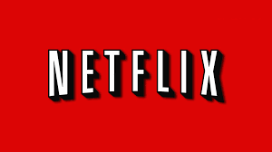

We know it is difficult to monitor everything your child is watching and therefore, to help, we wanted to give you notice about a particular series that is very popular on Netflix right now. 13 Reasons Why depicts the story of a high school child who commits suicide. The series contains very sensitive material that could be difficult for this age group. It also contains very graphic and violent content.
Please be aware that there is no age limit to watch these series. However, you are able to add a parental control to block certain shows of a particular rating. You are unable to block specific shows. Please click on the link below to see step-by-step instructions in how to use parental controls on Netflix: https://www.techjunkie.com/block-shows-netflix/
In addition, if your child has already viewed the show and wants to have a discussion about it, here is a link to some great talking points: https://www.jedfoundation.org/13-reasons-why-talking-points/
Please feel free to refer your child to the School Counselors as well. You can contact us directly at the following email addresses: dietrickn@friscoisd.org jonessara@friscoisd.org.

